Project1 3 Report
ShiqiXu

- Design a basic disk-storage system
  - Requirement

Implement a simulation of a physical disk, the sector size is 256 bytes, output the track-to-track time.
  - Usage
./disk <#cylinders> <#sector per cylinder> <track-to-track delay> <#disk-storagefilename>

  - Some instruction

I: Information request. The disk returns two integers representing the disk

geometry: the number of cylinders, and the number of sectors per cylinder.

R c s: Read request for the contents of cylinder c sector s. The disk returns

Yes followed by a writespace and those 256 bytes of information, or No if

no such block exists.

W c s data: Write request for cylinder c sector s. The disk returns Yes and

writes the data to cylinder c sector s if it is a valid write request, or returns

No otherwise.

E: Exit the disk-storage system.

  - Design details
    - Disk storage

I use a struct type to store the diskfile, the log_fp, and something else. So I can initial them in the initialize function, and can manipulate them together.
typedef struct{
char* filename;
int cylinders;
int sector_per_cylinder;
int fd;
double track_to_track_delay;
FILE*log_fp;
char*diskfile;

} disktype;
disktype disk;
    - Commands process

I classify the cmds from the cmd[0], if the cmd doesn’t attend this standard, just print the error message like the code below.
int parse_command(const char *cmd) {
char type;
int c, s;
char data[SECTOR_SIZE + 1];

switch (cmd[0]) {
case 'I':
return I_function();
break;
case 'R':
if (sscanf(cmd, "R %d %d", &c, &s) == 2) {
return R_function(c,s);
}
break;
case 'W':
if (sscanf(cmd, "W %d %d %256[^\n]", &c, &s, data) == 3) {
return W_function(c,s,data);
}
break;
case 'E':
return E_function();
break;
default:
fprintf(disk.log_fp, "Unknown command: %c\n", cmd[0]);
return -1;
}
return 1;
}
    - Main loop

In the main loop, I use fgets function to read data from the stdin, and use a variable to record it, if the status is -1, so just terminate the loop, and exit the procedure, and remove the ’\n’ signal to avoid cmd process error.
char cmd[CMD_BUFFERSIZE];
int status;
while (fgets(cmd, sizeof(cmd), stdin)) {
cmd[strcspn(cmd, "\n")] = '\0';//remove the n singnal
status=parse_command(cmd);
if(status==-1)
{
break;
}

    - Initialize disk system

I use the initialize function to initialize the disk system: including open the file witch we want to write in, set the track-to-track time,set the cylinders and sector_per_cylinder.look the code below.
Void initialize(int cylinders,int sector_per_cylinder,doubletrack_to_track_delay,char*filename){
present=-1;//initialize the two records,-1 refers to this is the first cylinder
disk.filename=strdup(filename);
disk.cylinders=cylinders;
disk.sector_per_cylinder=sector_per_cylinder;
disk.track_to_track_delay=track_to_track_delay;
disk.log_fp = fopen("disk.log", "w");
disk.fd = open (filename, O_RDWR | O_CREAT, 0);
//error...
long FILESIZE = cylinders*sector_per_cylinder*SECTOR_SIZE;
int result = lseek (disk.fd, FILESIZE-1, SEEK_SET);
//error...
result = write (disk.fd, "", 1);
//error...
disk.diskfile= (char *)mmap(NULL, FILESIZE,PROT_READ | PROT_WRITE,MAP_SHARED, disk.fd, 0);
if (disk.diskfile== MAP_FAILED){
close(disk.fd);
printf("Error: Could not map file.\n");
exit(-1);
}
}
    - Demo screenshot

Shell command:

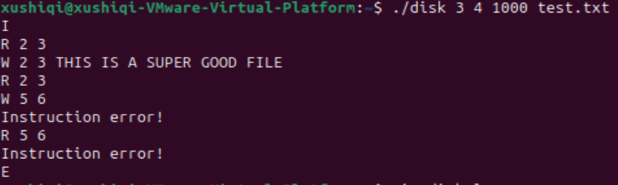

disk.log:

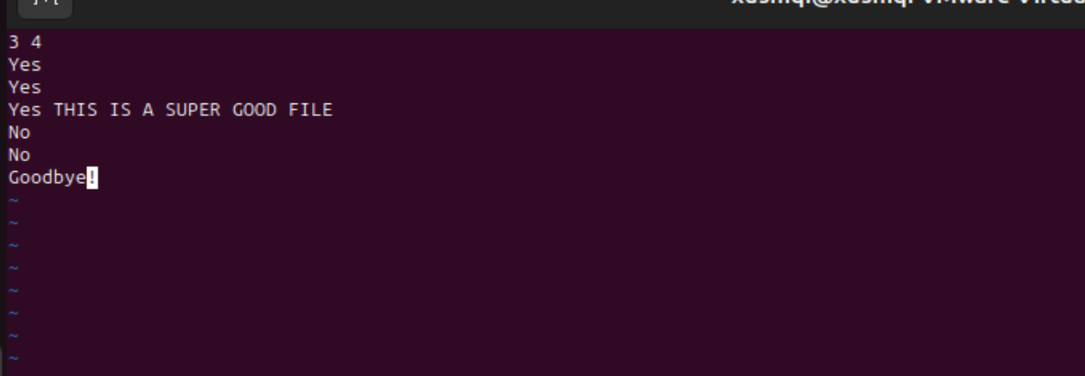

- Design a file system
  - Requirement

Implement a simulation of a file system, this system should operate several basic file system operations.
  - Usage
./fs

  - Some instruction

f: Format. This will format the file system on the disk, by initializing any/all

of tables that the file system relies on.

mkf: Create file. This will create a file named f in the file system.

mkdir d: Create directory. This will create a subdirectory named d in the

current directory.

rm f: Delete file. This will delete the file named f from current directory.

cd path: Change directory. This will change the current working directory to

the path. The path is in the format in Linux, which can be relative path or

absolute path. When the file system starts, the initial working path is /. You

need to handle . and ..

rmdir d: Delete directory. This will delete the directory named d in the

current directory.

ls: Directory listing. This will return a listing of the files and directories in the

current directory. You are also required to output some other information,

such as file size, last update time, etc.

cat f: Catch file. This will read the file named f , and return the data that

came from it.

w f l data: Write file. This will overwrite the contents of the file named f with

the l bytes of data. If the new data is longer than the data previously in the

file, the file will be made longer. If the new data is shorter than the data

previously in the file, the file will be truncated to the new length.

i f pos l data: Insert to a file. This will insert to the file at the position before

the posth character(0-indexed), with the l bytes of data. If the pos is larger

than the size of the file. Just insert at the end of the file.

d f pos l: Delete in the file. This will delete contents from the pos character

(0-indexed), delete l bytes or till the end of the file.

e: Exit the file system.
  - Design details
    - File system working principle

As you can see if figure1, the file system structure is divided into several parts:

Block: the size of the block is 256 bytes. The block is responsible for storing all the contents required by the file system, and controls read/write operations as well as block allocation and deallocation through a block control.

superblock: The superblock is used to store the allocation status of inodes and blocks. It also contains a magic number to determine whether it has been initialized, and a root_inode pointer that points to the inode of the root directory.

Inode_table:The inode table is used to store the block numbers where the inode files corresponding to a specific file or directory are located.

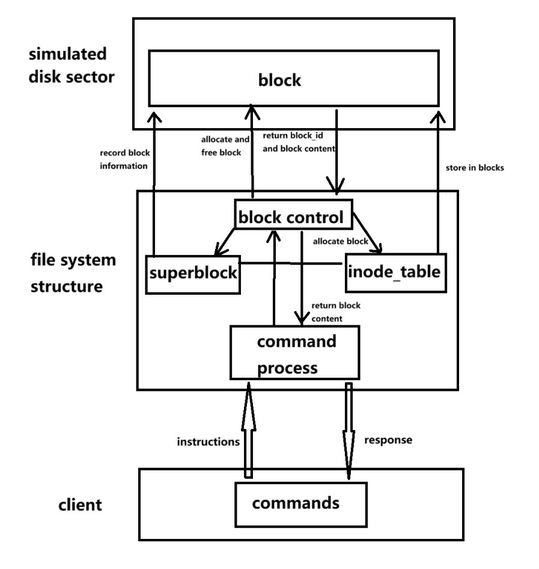

Figure1
    - Superblock structure

To simplify things, I've defined the blockcontrol module within the `superblock.h` header file, Superblock is block 0, which contains some information of the file system. MAGIC can be used to check if the disk is a valid file system, or in other words, to check if the disk is formatted.if the system is not formatted ,many basic commands can not be executed correctly .And some blockcontrol function includes :write_block，read_block，block_allocate，block_free,like this:
typedef struct{
uint32_t count_inode;//total inode
uint32_t count_block;//total block
uint32_t count_inode_free;//free inode
uint32_t count_block_free;//free block
uint32_t inode_map[NUM_INODE_MAP];//the inode bitmap
uint32_t block_map[NUM_BLOCK_MAP];//the block bitmap
uint32_t root_inode;
uint16_t magic;
}superblocktype;

int write_block(char*buffer,int block_0,int block_num){
if(block_0+block_num-1<0||block_0+block_num>TOTAL_BLOCK)return -1;
for(int i=0;i<block_num;i++){
memcpy(diskfile[block_0+i],buffer+i*MAX_BLOCKSIZE,MAX_BLOCKSIZE);
}
return 1;
}
int read_block(char*buffer,int block_0,int block_num){
if(block_0+block_num-1<0||block_0+block_num>TOTAL_BLOCK)return -1;
for(int i=0;i<block_num;i++){
memcpy(buffer+i*MAX_BLOCKSIZE,diskfile[block_0+i],MAX_BLOCKSIZE);
}
return 1;
}
int block_allocate(){
if(!sb.count_block_free)return -1;
for(int i=5;i<NUM_BLOCK_MAP;i++){//start from the non-sysblock
uint32_t space_block=sb.block_map[i];
for(int j=0;j<32;j++){
if((space_block>>(31-j)&1)==1)continue; else{
space_block=space_block|(1<<(31-j)); sb.block_map[i]=space_block;
sb.count_block_free--;
sb.count_block++;
char buffer[5*MAX_BLOCKSIZE];
memcpy(buffer,&sb,sizeof(sb));
if(write_block(buffer,0,5)==-1)return -1;
else{
return i*32+j;
}
}
}
}
return -1;
}
int block_free(uint32_t block_number){//it is a real number not a bitmap
if(block_number<SYS_BLOCK)return -1;
int map_num=block_number/32;
int offset=block_number%32;
uint32_t space_block=sb.block_map[map_num];
if((space_block>>(31-offset)&1)==0)return 0;
else{
space_block=space_block&(~(1U<<(31-offset)));
sb.count_block_free++;
sb.count_block--;
char buf_1[MAX_BLOCKSIZE];
memset(buf_1, 0, sizeof(buf_1));
if(write_block(buf_1,block_number,1)==-1)return -1;
char buf_2[5*MAX_BLOCKSIZE];
memcpy(buf_2,&sb,sizeof(sb));
if(write_block(buf_2,0,5)==-1)return -1;
return 1;
}
return -1;
}

    - Inode structure

The inode is used to store metadata about a file or directory, including its size, creation time, number of subdirectories, parent directory number, and the block numbers where its contents are stored. It consists of six direct blocks and one indirect block. Structure is like Figure2:

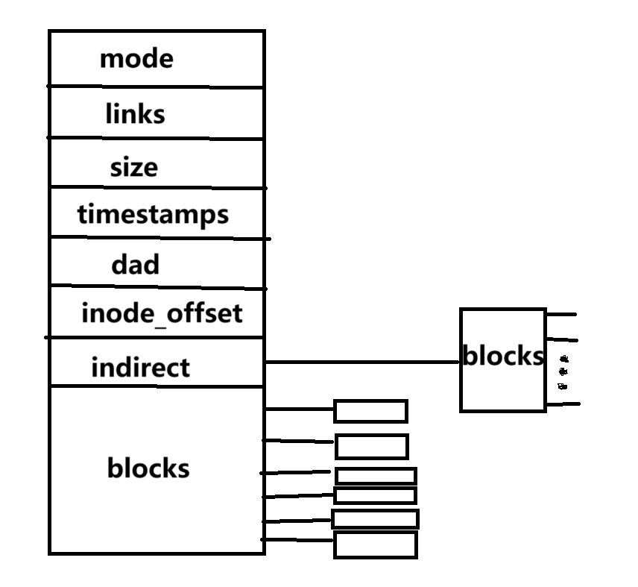

Figure 2

The code is like this:

typedef struct inode{
uint8_t mode; // 0:file 1:directory

uint8_t links; // the link count
uint16_t size; //file size
uint16_t blocks[inode_directblock_num];//--
uint16_t indirect;//--
uint32_t timestamps[2];//?
uint32_t dad;
uint16_t inode_offset;
}inode;//32 bytes
extern inode inode_table[TOTAL_INODE];

mode: Used to record whether the inode represents a file or a folder, distinguished by 0 and 1.

links: Indicates the number of blocks already allocated to the inode node.

size: Used to represent the number of bytes of file content.

blocks: Stores the block numbers it points to.

indirect: Records the numbers of indirect blocks.

timestamp: Records the creation time and modification time.

dad: Records the folder to which the file or folder belongs. If it is the root directory or an abnormal node, it is 0XFFFFFFFF, indicating that it has no (owning folder).

inode_offset: Used to store the corresponding number in the inode_table array.

    - Direntry struct

For files, the blocks store the actual file content. For directories, the blocks store directory entries encapsulated in the `direntry` structure. Each `direntry` is 32 bytes in size, meaning each 256-byte block can hold 8 directory entries, representing subfiles or subdirectories within the current directory. This `direntry` structure is only used by directory-type inodes.code is like this:

typedef struct direntry{//this is for the mkdir structure , of course ,it contain the inode root:"./home"
uint32_t inode_i;
uint8_t mode;
uint8_t valid;
char name[NAME_MAX];
}direntry;//32bytes

inode_i: Stores its number in the inode_table.

mode: Stores its type.

valid: Indicates whether the direntry is in an empty state. If valid is 0, it means it is available (or "free").

name: Stores the name of the file or folder it points to.

    - Command details

f function:

The first 160 bits of the block_map are set to 1, indicating they are occupied. This space is used to store the superblock and inode space, which belong to the system space and cannot be modified by user operations in terms of capacity. Originally, only 133 bits were required, but 27 bits are reserved for future expansion, making the total exactly 160 bits—a multiple of the block_map's 32-bit structure—to facilitate subsequent operations. Meanwhile, the basic parameters of the superblock are set, including the total number of supported inodes and blocks. Finally, the entire superblock is packaged and written into the first 5 blocks of the system, completing the initialization process.
void initial_superblock(){
sb.count_inode=0;
sb.count_block=133;
sb.count_inode_free=TOTAL_INODE;
sb.count_block_free=TOTAL_BLOCK-SYS_BLOCK;
memset(sb.inode_map, 0, sizeof(sb.inode_map));
memset(sb.block_map, 0, sizeof(sb.block_map));
for(int i=0;i<=4;i++){
sb.block_map[i]=0xFFFFFFFF;
}
char buffer[5*MAX_BLOCKSIZE];
memset(buffer, 0, sizeof(buffer));
memcpy(buffer,&sb,sizeof(sb));
write_block(buffer,0,5);
}

mk,mkdir function:

These two functions will call the add_in_dir function, passing in the mode type to initialize the file type of the corresponding inode, the name to initialize the name of the data pointed to by the inode, and the inode corresponding to the current directory's number in the inode_table, which is used to create a file or folder in the current parent directory. For the add_in_dir function, based on the principle of not wasting block space, it first checks blocks that have been used but are not yet full (since one block can accommodate 8 directory entries). It then sets the valid bit of the directory entry to 1, indicating that the current file or folder is allocated to this location, and initializes the corresponding directory entry with the name, inode number, type, and valid bit. If no used block is found (i.e., this is the first file/folder in the current parent directory, or there have already been a multiple of 8 files/folders before), a block space is allocated to the current parent directory, and the data is stored in this space.
int add_in_dir(inode*node,uint8_t mode,const char*name){
//...
direntry dirp[8];
for(int i=0;i<inode_directblock_num;i++){
if(node->blocks[i]==0)continue;
//...
for(int j=0;j<8;j++){
if(dirp[j].valid==0){
int new_inode_id=allocate_inode();
initial_inode(&inode_table[new_inode_id],mode,new_inode_id,node->inode_offset);
//...set dirp the inode_i,mode,valid
strcpy(dirp[j].name,name);
//...
return 1;
}
}
}
if(node->links<inode_directblock_num){
for(int i=0;i<inode_directblock_num;i++){
if(node->blocks[i]==0){
node->blocks[i]=block_allocate();
int new_inode_id=allocate_inode();
if(new_inode_id==-1)return -1;
initial_inode(&inode_table[new_inode_id],mode,new_inode_id,node->inode_offset);
//...set dirp the inode_i,mode,valid
//...
return 1;
}
}
}
return -1;
}

rmdir,rm function:

Just Like mk,mkdir command,but we just set the corresponding dirp valid bit as 0,to signal that this dirp is empty, can contain new file or folder.

cat function:

As with the above process, search for all dirps in the current parent directory. If a dirp's name matches the required name, call the low-level function read_block in the block control module to read the corresponding content and return it.

Ls function:

Traverse all dirps in the current parent directory. For any dirp with a valid bit set to 1, read its name and store it in the built-in name_array. After reading all files and folders, sort them lexicographically (files first, then folders), separate entries with spaces, and use & to distinguish files from folders. Finally, return the name_array as the list of files and folders in the current parent directory.

cd function:

The current parent directory can be switched. For example, entering cd .. switches to the parent directory. This requires calling the dad attribute of the current inode, which returns the number of its parent directory in the inode_table. The current directory number only needs to be updated to this new number. When entering cd <filename>, the program will locate the file in the current parent directory, obtain the inode_i stored in the corresponding directory entry (which is its defined number in the inode_table), and update the current directory number to this value. Below is an implementation.
int cd_func(char*path){
int store=now_dir;
char path_copy[CMD_BUFFERSIZE];
strncpy(path_copy, path, sizeof(path_copy));
path_copy[sizeof(path_copy) - 1] = '\0';
char* tmp = strtok(path_copy, "/");
while(tmp!=NULL){
if(strcmp(tmp,"..")==0){
now_dir=inode_table[now_dir].dad;
}
else if(strcmp(tmp,".")==0);
else{
if(inode_table[now_dir].mode==0){
printf("ERROR:this is not a directory\n");
now_dir=store;
return -1;
}
int result=find_from_dir(&inode_table[now_dir],tmp);
now_dir=result;
}
tmp=strtok(NULL,"/");
}
return 1;
}

You can see:I used strtok to parse the path string.

W,i function:

It only involves writing the corresponding content into the blocks pointed to by the file. You just need to locate the file in the current parent directory and write the content into the blocks it points to. For the i command, simply copy the original content, process it in the main program's buffer, and then write it back into the relevant blocks.

D function:

You only need to read back the content stored in the corresponding dirp, manipulate it in the main program, then truncate the result with the '\0' character and write the resulting string back to the original block. For the logic of writing back to the block, you need to check if the original block had sufficient allocation. Since I implemented dynamic allocation (files aren't initially allocated all their blocks; instead, blocks are allocated on-demand), the underlying layer implements logic for block allocation and deallocation. The following code snippet demonstrates this:

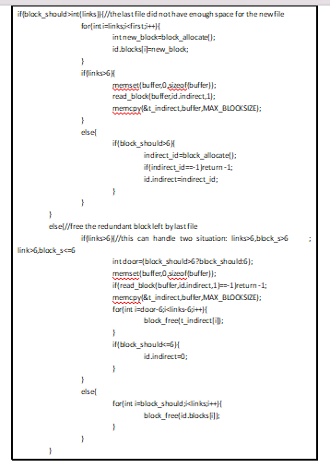

    - screenshot

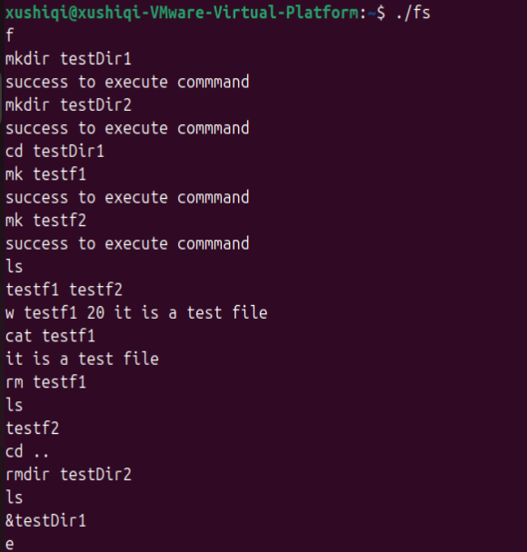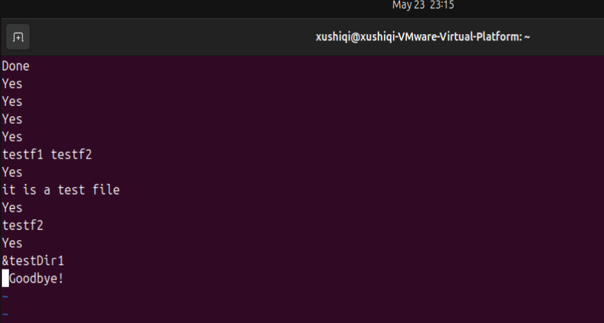

- work together
  - Requirement

combine the above three parts with socket

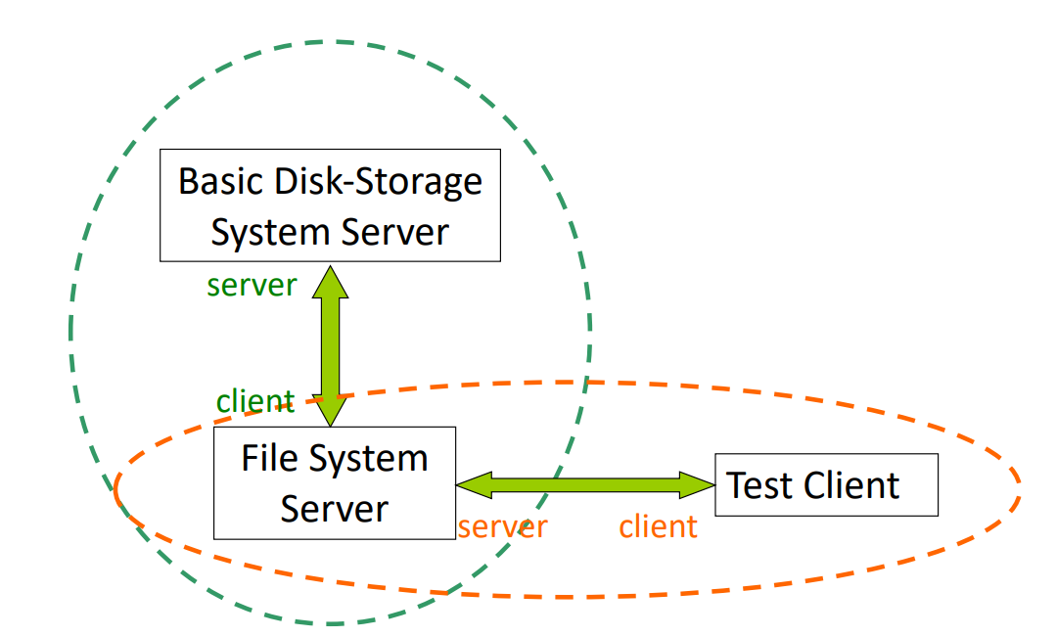
  - Usage
./disk <#cylinders> <#sectors per cylinder> <track - to - track delay> <#disk - storage - filename> <DiskPort>
./fs <DiskPort> <FSPort>
./client <FSPort>

  - Design detail

I implemented socket communication by establishing ports between the disk and fs components, as well as between fs and client. Data transmission is handled using send and recv functions. The most complex part lies in the communication between disk and fs. In the block control module of the fs header file, the block allocation logic had to be revised: instead of reading/writing to files created locally within fs (which would not persist data permanently, as all user information is lost when the fs process exits), all block allocation logic is now transmitted via socket communication to the disk for storage.

typedef struct {
char op;
int blockno;
char data[SECTOR_SIZE];} __attribute__((packed)) DiskRequest;

I utilized a structure to package the transmitted data. This structure is exclusively used for communication between the disk and fs components.

op: The operation to be performed on the disk end, 分为两种类型: 'R' (read) and 'W' (write).

block_no: The block number to be operated on. This number will be converted into the corresponding cylinder and sector on the disk end.

data: The relevant data.

